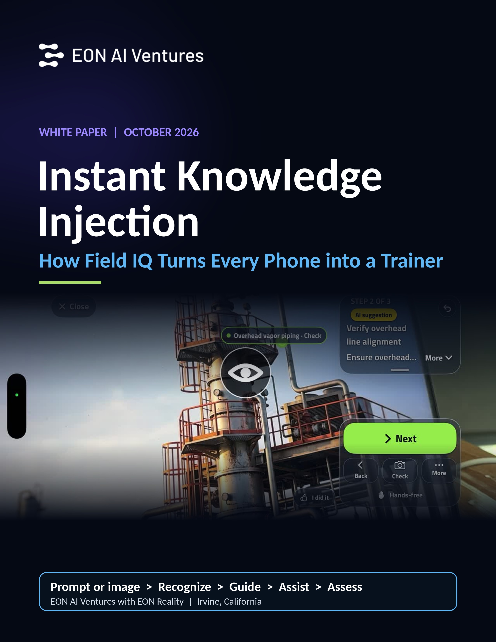

WHITE PAPER | EON AI VENTURES WITH EON REALITY | OCTOBER 10, 2026
Instant Knowledge Injection
How Field IQ Turns Every Phone into a Trainer
Thesis
Knowledge transfer has always been episodic: people learn on a schedule and need to know on demand. Field IQ removes the gap. From a prompt or a picture, it recognizes what is in front of you, then guides you, assists you, and assesses you in seconds, on the phone you already carry. That changes training from an occasional event into knowledge injected at the moment of need, and it totally revolutionizes how knowledge moves from those who have it to those who need it.

Contents
Executive summary
1. Why training has been episodic
2. The speed curve
3. How Field IQ works
4. The guide, assist, assess loop
5. Where it works
6. The demos: use cases in practice
7. Education: when the book opens up
8. Knowledge sources and governance
9. Scaling to thousands of procedures
10. Implications for enterprises, educators, and governments
11. Field IQ in the Intelligence Flywheel
12. Next steps
Appendix: the demo videos

Executive summary
For as long as organizations have trained people, training has been something that happens occasionally. People travel to a training center, sit through a course, or work through a module, and then return to the job hoping the knowledge is still there when the moment arrives. The moment rarely arrives on schedule. It arrives on a night shift, at an unfamiliar machine, in front of a patient, or on a remote site.
Field IQ now closes that gap. Its new instant knowledge injection capability scales to literally thousands of instructions on anything, using one simple process: a prompt or an image goes in; Field IQ recognizes what it is; then it guides the user, assists the user, and assesses the user. If there is more time, the user clicks Next Step and Field IQ generates a full 3D model to train on. If the physical equipment is there, the user works on the physical equipment. If it is not, a picture, a screen, a billboard, or a book is enough.
Key points:
- From occasional to instant. Training moves from a scheduled event to knowledge delivered the moment it is needed.
- Seconds, not months. Building a simulation used to take months; EON's earlier AI-assisted simulation authoring brought it to about half an hour; Field IQ now delivers guidance, assistance, and assessment in seconds.
- Point at anything. Field IQ works from physical equipment, photos, pictures on a website or screen, billboards, and books.
- Guide, assist, assess. Every session runs the full loop and ends with a report: start time, time taken, parts named, steps completed.
- Your knowledge, governed. Knowledge comes from your own documents, online documents, expert know-how, Ask Tacit, or AI, with human escalation and a complete record.
- Proven across sectors. Today's demos cover oil and gas, healthcare, defense, mining, aerospace, and agriculture, plus a clear path into education.
- Massive reach. Some 7 billion people have a phone. Each phone can now be a trainer.

1. Why training has been episodic
The way people learn work has changed shape several times, but one thing has stayed constant: it has been organized around events, not around moments of need.
Era | How knowledge moved | The constraint
Apprenticeship | Side by side with a master, on the job | One expert, a few learners, years of time
Classroom and training center | Scheduled courses, away from the work | Travel, timetables, and forgetting before use
Manuals and SOPs | Written procedures on paper or file shares | Hard to find and hard to apply at the machine
E-learning | Self-paced modules on a screen | Generic content, separated from real equipment
Simulation and XR | Realistic practice in 3D | Slow and costly to build; months per simulation
Field IQ instant knowledge injection | Recognition, guidance, assistance, and assessment on the phone | Seconds, on demand, on anything

Each step improved quality or access, but none removed the basic problem. Learning happened when the course was scheduled; need happened when the job demanded it. Organizations compensated with refresher courses, binders, and the senior person who always knows the answer. When that person is on another shift, on another site, or retired, the knowledge is not there.
The constraint was never motivation. It was the cost and time of producing the right instruction for the right object at the right moment. That is exactly the constraint Field IQ now removes.

2. The speed curve
The key is speed. Three points on the curve tell the story:
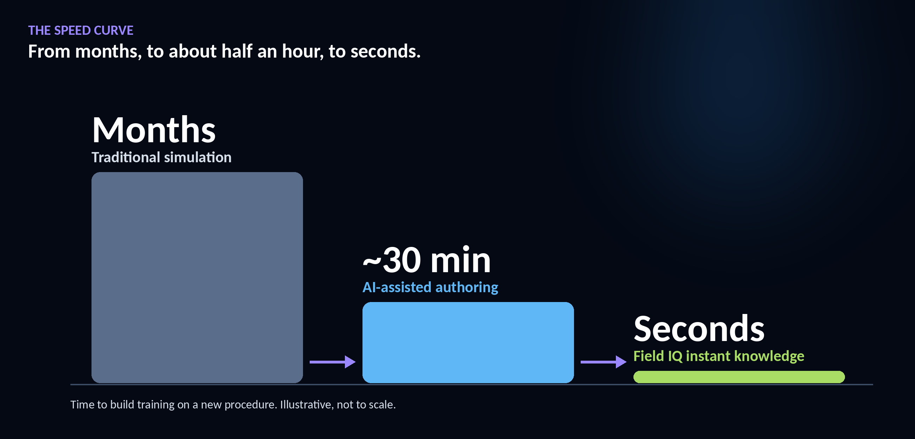
Figure 1. Time to build training on a new procedure. Illustrative, not to scale.
Stage | Time to build | What it means
Traditional simulation | Months | Building a training simulation took specialist teams and months of work.
AI-assisted authoring | ~30 min | EON's earlier AI-assisted simulation authoring brought building a simulation down to about half an hour.
Field IQ instant knowledge | Seconds | Recognition, guidance, assistance, and assessment, from a prompt or picture.

The same compression applies to the work itself. Guidance, assistance, and assessment that used to take hours, finding the manual, locating an expert, walking through the steps, writing up the result, now take seconds. Field IQ's reports make that visible: across the demos, complete guided procedures took between 29 and 56 seconds from start to report. In the mining demo, building the same thing as a 3D simulation would take roughly half an hour; Field IQ did it in about a minute.
When the time to produce an instruction drops from months to seconds, the economics change completely. It is no longer necessary to decide in advance which few procedures justify a simulation. Every machine, every picture, and every page can have one, on demand.

3. How Field IQ works
The process is deliberately simple. It starts with whatever the user has: a question typed as a prompt, or a camera pointed at something.
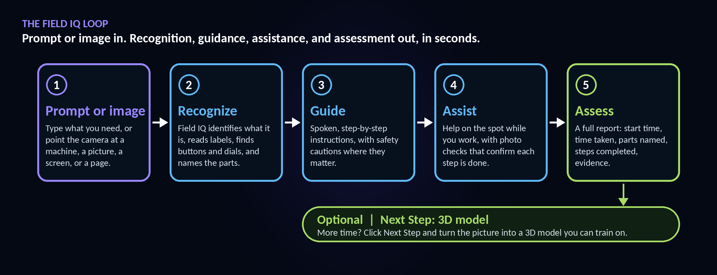
Figure 2. The Field IQ process, with the optional Next Step to a 3D model.
Step | What Field IQ does
Prompt or image | Type what you need, or point the camera at a machine, a picture, a screen, or a page.
Recognize | Field IQ identifies what it is, reads labels, finds buttons and dials, and names the parts.
Guide | Spoken, step-by-step instructions, with safety cautions where they matter.
Assist | Help on the spot while you work, with photo checks that confirm each step is done.
Assess | A full report: start time, time taken, parts named, steps completed, evidence.
Next Step: 3D | With more time, click Next Step and turn the picture into a full 3D model you can train on.

Recognition is the foundation. In the demos, Field IQ spots regions in the image, finds buttons and dials, reads labels, names parts, works out the order of operations, and writes the steps. It does this from the real machine, from a photo, from a picture in a book, or from an image on a website or screen. Recognized machines are saved, so the next time the user returns, they are already there.

4. The guide, assist, assess loop
Most tools stop at information. Field IQ completes a loop that mirrors how an expert teaches: show me, help me, check me.

Guide
Field IQ gives spoken, step-by-step instructions at the point of work. Safety cautions appear where they matter, for example isolating a discharge valve, checking pressure, or locking out a standby pump before going further.

Assist
While the user works, Field IQ stays with them. It names the part they are looking at, explains what to look for, and uses photo checks to confirm that each step is actually done before moving on.

Assess
At the end, Field IQ produces a full report: the start time, the time taken, the parts named, and which steps were completed, together with an evidence pack. Assess reports can be sent on to Assess IQ, so the same session that taught the task also documents competence.
Why the loop matters
Guidance without assessment leaves organizations guessing. Assessment without guidance arrives too late. Running all three in one session, in seconds, means every use of Field IQ both helps the person in front of the machine and leaves a verified record behind.

5. Where it works
If the physical equipment is there, the user does the procedure on the physical equipment. If it is not, Field IQ works from a picture. That flexibility is what lets one capability serve the field, the classroom, and everything in between.
Surface | How it is used
Physical equipment | Work the procedure on the real machine in front of you.
In the field | On site, on shift, at the asset, with the phone already in your pocket.
In simulation | Practice on a 3D model generated from the same picture, in your own room.
Billboards and pictures | A photo, a poster, a website, or an image on a screen is enough to start.
Books | Point at a textbook page and it guides you. The anatomy book opens up.
Screens and websites | Recognition works from pictures on a website or on screen, so remote teams can start from a shared image.

6. The demos: use cases in practice
On October 10, 2026, Dan Lejerskar recorded a series of 12 live demos of Field IQ on a phone, now public on YouTube. The use cases below are drawn directly from those recordings. Watch them at https://eon-field-iq-videos.vercel.app.

Oil & Gas

Demo 1: Guided Pump Isolation from a Photo
There is no 3D model here, and none is needed. Pointed at pictures of oil and gas equipment, Field IQ's Recognize mode identifies the machine, reads the controls, and names the parts. It then talks the user through a pump isolation and lockout procedure step by step, with safety cautions at the points that matter: isolate the discharge valve, check the pressure, lock out the standby pump. The knowledge behind the steps can come from the operator's own permits, operation manuals, and SOPs, from documents found online, from expert know-how, or be built with AI. When the job is done, a full report records the start time, the parts that were named, and which steps were completed. The same approach covers a wide range of oil and gas assets, from pumps to three-phase separators, emergency shutdown systems, and a condensate stabilizer column.
Segment: Oil & Gas | Length: 4:29 | Video: https://youtu.be/DU00KBWeuWY

Demo 2: Condensate Stabilizer Startup Checks
A single picture of an oil and gas facility is enough. Field IQ spots regions in the image, finds buttons and dials, reads labels, and names parts such as the overhead vapor piping, the stabilizer column, and the reboiler exchanger. The user chooses where the knowledge comes from: AI knowledge, documents found online, expert know-how, Ask Tacit, or their own documents. Field IQ then guides a startup check with safety cautions: inspect the column base level, verify the overhead line alignment, check the process isolation valve status. Very quickly a full report appears with the time taken, the start time, and the parts named, supporting understanding, guidance, and assessment in one pass. And when there is more time, the same picture can be converted into a 3D model, so the procedure can be practiced on the model in the user's own room.
Segment: Oil & Gas | Length: 3:28 | Video: https://youtu.be/FED6aA08J3o

Mining

Demo 3: Grinding Mill Lockout & Inspection Prep
Pointed at a picture of a mining grinding mill, Field IQ spots regions, buttons, dials, and switches in real time and identifies the grinding mill, the switch panel, the inching drive, the lubrication line, and the drive motor assembly. It then guides a lockout and hatch-inspection prep procedure with safety cautions: group lockout, isolate the lubrication supply, check system pressure, engage the inching drive lever. Knowledge can come from AI, documents online, expert know-how, your own documents, or Tacit, which captures experience. The whole procedure took about a minute and ended with a full report and evidence that can be shared or sent to Assess IQ. Building the same thing as a 3D simulation would take roughly half an hour. The machine is saved, and the same guidance works on the real equipment.
Segment: Mining | Length: 3:10 | Video: https://youtu.be/r6Vi0P9hg3c

Demo 4: Haul Truck Wheel Removal, Guided & Assessed
From a photo of a mining haul truck, Field IQ spots the region and identifies six parts, including the front wheel, the heavy-duty support stand, and the truck itself. It guides a wheel-removal procedure with safety cautions: chock the rear wheels, position the support stand, expose the wheel hub. Image-based step checks, such as confirming the wheel chocks are in place, add extra comfort. The rehearsal took 56 seconds and produced a full assessment report. Knowledge can come from your own manual, documents online, or expert know-how; normally the manual also tells Field IQ which parts to identify.
Segment: Mining | Length: 2:31 | Video: https://youtu.be/3WlUGRNamF0

Aerospace

Demo 5: Satellite Clean Room Test Stand Guidance
In a satellite clean room, Field IQ reads the labels and identifies the parabolic reflector antenna, the satellite test assembly, the grounding bonding cable, and the rotary positioning system. It guides a short payload-rotation procedure on the rotary test stand, with safety cautions: check the purge line connections, then rotate the test stage into position. Here the steps came from AI knowledge rather than the maker's manual, and the report shows where every step came from. The whole procedure took 29 seconds, with timing per step compared against the procedure.
Segment: Aerospace | Length: 1:58 | Video: https://youtu.be/dL043OrIBc8

Demo 6: Jet Engine Inspection, Verified in Seconds
Field IQ recognizes a jet engine from a picture and identifies parts such as the fan section. The user picks what to be guided on and chooses the source: AI knowledge, documents online, or experts. A three-step inspection follows: fan blades for foreign object damage, mounting pins on the stand, and transport stand wheel locks, with each step confirmed as done. The report records the start time, that the session used a photo rather than real equipment, the parts identified, and that the steps came from AI knowledge. It works the same on a 3D model, a picture, or the real equipment, and guidance and verification happened literally in seconds.
Segment: Aerospace | Length: 2:08 | Video: https://youtu.be/zPQ3CSDFU6I

Healthcare

Demo 7: Anesthesia Check, Engine Swap
This demo crosses two industries in one sitting, again using only pictures. Field IQ recognizes an anesthesia machine and an armored vehicle engine. In each case it spots regions, reads labels, finds the parts, works out the order, and writes the steps. In the medical example it guides a pre-use machine check covering vaporizer levels, the breathing circuit inspection, and the gas flow meters, and the report shows the check took 36 seconds. In the defense example it guides the user to make the vehicle safe, open the engine hatch, disconnect the power pack, and hoist it out, with safety cautions and photo checks that confirm each step is done. Recognized machines are saved, so the next time the user comes back they are already there. The same recognition works across healthcare, defense, mining, and aerospace.
Segment: Healthcare & Defense | Length: 5:41 | Video: https://youtu.be/tBj6RQXEoKw

Demo 8: ICU Hospital Bed Positioning Guidance
Without access to a real operating room, Field IQ works from pictures. It recognizes an ICU bed, identifies its components, and suggests a job: adjust the hospital bed position. The steps can come from AI knowledge or the hospital's own documents and materials. Field IQ guides the user to locate the bed control handset and adjust the bed elevation, then the report confirms it is an ICU bed, that the session used a photo, the six parts identified, and which steps were done correctly. The system does not care whether it is looking at a picture or the real thing: training when you need it, as you need it.
Segment: Healthcare | Length: 2:12 | Video: https://youtu.be/vfswfaUaDJ4

Defense

Demo 9: Armored Vehicle Engine Removal Guidance
From a picture of an armored vehicle, Field IQ builds the instructions for an engine replacement, a maintenance, repair, and operations procedure, in literally seconds, and identifies the parts. It guides each step with safety cautions: open the engine compartment hatch, attach the hoist rigging, lift the engine clear of the bay. Photo checks verify each step in a few seconds, for example confirming the engine access panel is fully open. The report captures the time, that the session used a photo, the vehicle type, and what was done and confirmed. It is also a refresher on steps learned in school, based on the classroom material.
Segment: Defense | Length: 2:29 | Video: https://youtu.be/F2vTPhxtQ4I

Demo 10: Ship Engine Room Emergency Stop Procedure
Field IQ recognizes a ship engine room from an image, identifying the fire hose station, the upper pipe, and the control panel, and suggests jobs including local engine start, emergency engine stop, rigging the fire hose, and an engine enclosure inspection route. It guides an emergency-stop procedure with safety cautions: perform the emergency shutdown, verify status on the display panel, isolate the fluid line. The procedure can come from documents online, expert know-how, or your own documents. It took 41 seconds: simple to use, even though it can handle very complex data, and a refresher on unique procedures learned months or years ago.
Segment: Defense / Naval | Length: 2:22 | Video: https://youtu.be/0MZ-eo71G34

Agriculture

Demo 11: Nutrient Dosing Station Startup Check
Field IQ helps farmers modernize, even those who do not know the latest technologies. From a picture of a nutrient dosing station, it finds the buttons and dials and names the water pressure gauge, the touchscreen controller, the pH and EC probe manifold, the pipelines, and the stock drums, and suggests procedures such as pH alarms, probe calibration, and mixing nutrient stocks safely. Knowledge can come from AI, your own documents, or expert knowledge. It guides a fertigation check: check system pressure, inspect pH and EC readings, open the line isolation valve, verify the dosing pumps. The whole check took 47 seconds, and the report notes that it was a photo, the 11 parts named, and which steps were confirmed done.
Segment: Agriculture / Modern Farming | Length: 2:38 | Video: https://youtu.be/ZmQ2n3t_r2Y

Demo 12: AI-Guided Vertical Farming Procedures
In a vertical farm, the operator points a phone at the hydroponic system and Field IQ recognizes the control panel. It then walks the operator through a nutrient-valve procedure step by step, right at the machine. When the procedure is finished, a full report with step timing and an evidence pack is generated automatically, along with Assess reports. This is knowledge injection when you need it, delivered in seconds, in an industry far from the refinery and the hospital.
Segment: Agriculture / Vertical Farming | Length: 2:02 | Video: https://youtu.be/3Q2rujqbDXg
Taken together, the demos show the same pattern across very different settings: recognition from a picture, guided steps with safety cautions, confirmation that the work is done, and a report at the end, all in seconds.

7. Education: when the book opens up
The use cases go well beyond industry. Point a phone at a book and Field IQ guides you. Point it at an anatomy book and the anatomy opens up: the picture on the page becomes the starting point for guided exploration, and with Next Step, a 3D model the learner can study from every angle.
For educators, this changes what a textbook is. Every diagram, photo, and figure becomes interactive. Students can be guided through a concept the moment they meet it, assisted when they are stuck, and assessed on what they have understood, without waiting for a lab session or a specialist resource. Because it runs on a phone, it reaches learners wherever they are.
- Textbooks: turn printed figures into guided explanations and practice.
- Anatomy and life sciences: open up anatomy pictures into explorable models.
- Technical and vocational education: learn procedures from pictures of equipment before touching the real thing.
- Lifelong learning: anyone can point at something unfamiliar and learn it on the spot.

8. Knowledge sources and governance
Speed is only valuable if the knowledge is right. Field IQ lets the user, or the organization, choose where the knowledge for each procedure comes from.
Knowledge source | What it brings
Your own documents | Permits, operation manuals, SOPs, and the equipment manual.
Online documents | Documents Field IQ finds online for the recognized equipment.
Expert know-how | The judgment of experienced people, captured and reused.
Ask Tacit | Draws on EON Tacit, which preserves the living memory of experts.
Built with AI | AI-built instructions when no document exists yet.
The equipment manual | The maker's own instructions for the recognized machine.

Governance by design
Field IQ was built on the principle that AI never gets the final say, on its own, on a step that could hurt someone. Instant knowledge injection keeps the same guarantees:
- It asks when unsure. On a safety-critical step, an uncertain assistant stops and escalates to a human. It does not bluff.
- Everything is on the record. Steps, photo checks, timing, and outcomes are logged in a full report and evidence pack, ready for supervisors and auditors.
- It checks itself first. Field IQ's approach is to challenge procedures before they are published, so only what survives goes live.
- The organization controls the source. Using your own documents, permits, manuals, and SOPs keeps guidance consistent with how your operation actually runs.
- Verified completion. Photo checks confirm each step is done, and assessment reports can flow to Assess IQ for formal competency records.

9. Scaling to thousands of procedures
Traditional training libraries grow one course at a time. Field IQ's library grows every time someone points a phone at something. Because recognition and step generation work from a picture, there is no need to build a 3D model or author a course before the first use. Because knowledge can be drawn from existing documents, expert know-how, or AI, the content does not have to be written from scratch. And because recognized machines are saved, every new machine becomes a permanent part of the library.
That is how Field IQ scales to literally thousands of instructions on anything. In oil and gas alone, the demos already span pumps, three-phase separators, emergency shutdown systems, and a condensate stabilizer column. Across all 12 demos, the same process handles grinding mills and haul trucks, satellite test stands and jet engines, anesthesia machines and ICU beds, armored vehicles and ship engine rooms, and dosing stations and vertical farms. It also suggests related jobs for each recognized machine, such as pH alarms and probe calibration on a dosing station, or local engine start and fire hose rigging in an engine room.

10. Implications

For enterprises
- Put guidance in front of every worker at the moment of need, not weeks before or after.
- Turn existing manuals, SOPs, and expert know-how into guided, assessed procedures in seconds.
- Capture a verified record of how work is actually done, every time a procedure runs.
- Train on equipment that is in production, offshore, or far away, using pictures and 3D models.

For educators
- Make every textbook figure interactive and every student's phone a tutor.
- Give learners guidance, help, and assessment the moment they meet a new concept.
- Extend hands-on learning to pictures of equipment and anatomy that schools could never stock.

For governments
- Reach citizens and workforces at national scale through the phones they already own.
- Accelerate workforce programs in critical sectors such as energy, healthcare, defense, and agriculture.
- Pair speed with governance: human escalation, full reports, and an auditable record.

11. Field IQ in the Intelligence Flywheel
Field IQ is one station in EON's Intelligence Flywheel, the self-reinforcing loop that captures expert judgment, puts it in front of every worker, verifies what actually happens, and gets better with every job.
Station | Role in the loop | How instant knowledge injection connects
Genesis | Turns expert knowledge into governed, step-by-step 3D simulations | Deep, 3D practice when there is more time
Field IQ | Delivers the procedure at the point of work | Now from a phone pointed at anything, in seconds
Assess IQ | Verifies competency and records manual versus reality | Receives Field IQ's assess reports and evidence
Work Intelligence | Compounds verified work into organizational knowledge | Every recognized machine and report makes the next one smarter

12. Next steps
- Watch the demos at https://eon-field-iq-videos.vercel.app to see recognition, guidance, assistance, and assessment live.
- Pick a starting set of equipment or materials: the machines, pictures, or books where knowledge is most needed.
- Choose the knowledge sources for each: your own documents, online documents, expert know-how, Ask Tacit, or AI.
- Run guided, assessed sessions and review the reports with supervisors or instructors.
- Contact EON AI Ventures at www.eonaiventures.com to discuss deploying instant knowledge injection.
In Dan Lejerskar's words
Learning and training used to be something you did occasionally. You went to a training center, or you took a course. Field IQ takes that concept to the next level: instant knowledge injection, exactly when you need it. You point your phone, it recognizes what it is, and it guides you, assists you, and then assesses you. Some 7 billion people have a phone. Every one of them can now have a trainer in their pocket.
Dan Lejerskar, Founder and Chairman, EON Reality and EON AI Ventures

Appendix: the 12 demo videos
All videos are public on YouTube. Video page: https://eon-field-iq-videos.vercel.app
# | Video title | Segment | YouTube link
1 | Oil & Gas: Guided Pump Isolation from a Photo | Oil & Gas | https://youtu.be/DU00KBWeuWY
2 | Oil & Gas: Condensate Stabilizer Startup Checks | Oil & Gas | https://youtu.be/FED6aA08J3o
3 | Mining: Grinding Mill Lockout & Inspection Prep | Mining | https://youtu.be/r6Vi0P9hg3c
4 | Mining: Haul Truck Wheel Removal, Guided & Assessed | Mining | https://youtu.be/3WlUGRNamF0
5 | Aerospace: Satellite Clean Room Test Stand Guidance | Aerospace | https://youtu.be/dL043OrIBc8
6 | Aerospace: Jet Engine Inspection, Verified in Seconds | Aerospace | https://youtu.be/zPQ3CSDFU6I
7 | Healthcare & Defense: Anesthesia Check, Engine Swap | Healthcare & Defense | https://youtu.be/tBj6RQXEoKw
8 | Healthcare: ICU Hospital Bed Positioning Guidance | Healthcare | https://youtu.be/vfswfaUaDJ4
9 | Defense: Armored Vehicle Engine Removal Guidance | Defense | https://youtu.be/F2vTPhxtQ4I
10 | Defense: Ship Engine Room Emergency Stop Procedure | Defense / Naval | https://youtu.be/0MZ-eo71G34
11 | Agriculture: Nutrient Dosing Station Startup Check | Agriculture / Modern Farming | https://youtu.be/ZmQ2n3t_r2Y
12 | Agriculture: AI-Guided Vertical Farming Procedures | Agriculture / Vertical Farming | https://youtu.be/3Q2rujqbDXg

About EON Reality and EON AI Ventures
EON Reality, based in Irvine, California, is the world's leading company in immersive learning and knowledge transfer. Its flagship solutions, EON Genesis, EON-XR, EON Assess IQ and Venture Builder, enable millions of users to create and deploy experiential learning content. www.eonreality.com
EON AI Ventures is a dedicated AI platform company focused on scalable enterprise transformation and workforce capability, founded by the leadership behind EON Reality to accelerate delivery of AI-powered workforce solutions across industries and institutions. www.eonaiventures.com

